**Brooklyn torah gazette**

**For parshas terumah 5782**

Volume 6, Issue 20 (Whole Number 275) 4 Adar I 5782/ February 5, 2022

**Printed L’illuy nishmas Nechama bas R’ Noach, a”h**

For a free subscription, please forward your request to [***keren18@juno.com***](mailto:keren18@juno.com)

**The First Rabbi in America**

**By Yitzchok Levine**

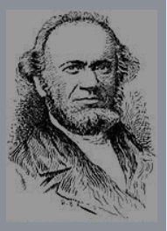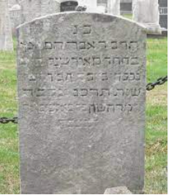

**Rabbi Abraham Rice, zt”l and his tombstone**

The first musmach to settle in America - Abraham Joseph Reiss (son of Meir) was born in either 1800 or 1802 in Gochsheim, Germany, a provincial town near Wurzburg. (His name was later Americanized to Rice.) When he was about a year-and-half-old he fell and injured his leg, resulting in him limping for the rest of his life.

He received an intensive Jewish education. His parents introduced him to the study of Chumash and Gemara at an early age, and he eventually studied at the Wurzburg Yeshiva headed by Rabbi Abraham Bing (1752–1841). Rabbi Rice received smicha from Rav Bing and later continued his studies at the yeshiva of Rabbi Wolf Hamburger (1770–1850) in Furth.

In short, Rabbi Rice became a first rate talmid chacham (Torah scholar) who was imbued with a deep sense of loyalty to Torah values. At the age of 30, he became a Talmud instructor in the yeshiva in Zell, where in the mid-1830s he met and married Rosalie Leucht (b. about 1810). In 1840, Rabbi Rice, his wife, and his sister sailed from Hamburg on the Sir Isaac Newton, arriving in New York on July 25, 1840.

Soon after his arrival in the United States, he followed the advice of his friends and settled in Newport, Rhode Island. He heard about the historic Congregation of Newport [Touro Synagogue], the first Congregation that was founded in Colonial days and became famous as a result of the visit of George Washington. It was that Congregation which received the historic letter from the first President in which he said that “the children of the stock of Abraham” may happily live in this land “by right” and not by sufferance.

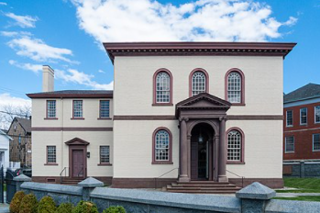

**Touro Synagogue in Newport, Rhode Island**

Rabbi Rice soon learned to his deep disillusionment that in spite of the historic Synagogue, the Jewish community in Newport had dwindled to a handful of people, and there was little prospect of rejuvenating this Congregation."

Rav Rice then returned to New York, where he met Aaron Weglein, a landsman of his who was the president of the Baltimore Hebrew Congregation (Nidchei Yisroel), which had been founded in 1829. Weglein realized that his congregation had the opportunity to obtain the services of a real rabbi, and the first rabbi in the country at that!

He invited Rabbi Rice to become the spiritual head of his shul, and Rav Rice accepted. So it was that Rav Rice and his family arrived in Baltimore in late August of 1840. At first glance, Rabbi Rice and Congregation Nidchei Yisroel, which was also known as the “Stadt Shul” of Baltimore, since it was at this time the only shul within the city boundaries, seemed to be the perfect match.

Many of congregants were from Bavaria, as was the rabbi. The synagogue was Orthodox and so was the rabbi. Rabbi Rice considered it his mission to strengthen Orthodoxy in America, and the Baltimore Hebrew Congregation was proud of its observance of Jewish religious tradition.

However, Rabbi Rice soon found himself at odds with many of those who davened in his shul. The misunderstandings began with the question of Sabbath observance. True, the Baltimore Jews were Orthodox and would have loved to observe the Sabbath as befits traditional Jews.

Peddlers, however, very often found it impossible to keep the Sabbath or, for that matter, kashrut. There were also members of the congregation who surreptitiously – and some even quite openly – kept their stores open on Saturdays." New immigrants began to arrive in Baltimore during the 1840s, and many of them were not fully observant.

Still, they wanted to be called to the Torah when they came to shul. The problem of giving aliyos to those who were not shomer Shabbos became a source of serious irritation between the rabbi and many of his congregants. Refusing to accept these double standards, Rabbi Rice at first directed that those who did not keep Shabbos should not be given aliyos. (Continued next week)

*Reprinted from the Parshat Terumo 5782 email of whY I Matter, a parshasheet edited by Yedidye Hirtenfeld for the Young Israel of Midwood in Brooklyn.*

**Thoughts for Our Parsha**

*And you shall make the boards for the Tabernacle* (Exod. 26:15):

The boards for the Tabernacle were made of acacia wood from trees which Yaakov had planted in Egypt. He told his children to take the wood with them when they left Egypt. Though the wood was over 200 years old, the Jews didn't send for fresher wood from a nearby country. This teaches us on what the true foundation of a Jewish home ought to be based.

When each new generation sets up their homes, they often think they have to update and modernize their ideals. By mentioning the wood that Yaakov had planted so long ago, the Torah is telling us that a Jewish home should be based on the tradition and heritage of our ancestors. *(Targum Yonatan ben Uziel)*

*Reprinted from the Parshat Teruma 5757/1997 edition of L’Chaim. Adapted from Vedibarta Bam by Rabbi Moshe Bogomilsky*

*.*

**Rabbi Berel Wein**

**On Parshas Terumah**

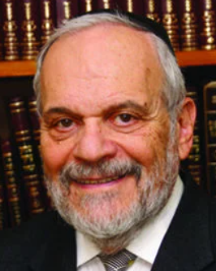

It is interesting to note the choice of verbs used by the Torah, regarding the collection of materials that will be necessary in the building of the Mishkan in the desert of Sinai. The Torah places emphasis on the collectors and takers of the donations and does not emphasize the intent on the part of the givers. It is true that the Torah instructs Moshe that he should take from those who have a heart that is willing to voluntarily give.

The emphasis in the verse is that everything should be taken on behalf of G-d and the holy noble project which is being undertaken – the building of a physical Tabernacle that will have within it the ability to somehow capture the spiritual and moral greatness of the Torah and of the people of Israel.

I have been in Jewish public life for well over 65 years. In those years, I have been engaged in building schools, synagogues, Torah learning platforms, book publishing and film production. I can testify that without raising funds and collecting money from others to sponsor and facilitate these projects, it would be impossible to see any to fruition. So, one must learn and train oneself to become a taker.

For many years, I foolishly dreamt that, somehow, I would win the lottery or otherwise become wealthy enough to sponsor the projects that I had in mind to accomplish with my own funds. I would never have to ask anyone for money to fulfill my ambitions and complete my projects. As you can well understand, Heaven has mocked my dreams of personal wealth, as all projects have required intensive and continuous fundraising on my part. Since, by nature, I never have liked to ask people for favors or donations, all of this has been a trying experience.

However, the great Rabbi Yosef Kaheneman taught me a valuable lesson during the years that I was able to accompany him in Miami Beach on his fundraising visits and forays. He taught me that the taker who was asking for the money was really the one that was doing the ultimate favor for the giver who  was writing the check. He used to tell me every morning before we journeyed to visit people, that we were going to do a great favor today for these Jews, by requesting their help in building Torah in the land of Israel. And he said this to me in sincerity.  Even when we were rebuffed, and for various reasons left empty-handed, he would remark to me that some people just did not know how to grasp an opportunity and appreciate the favor that is being done for them.

Heaven instructs Moshe to help others participate in projects of eternity and holiness. And I imagine that this is the proper attitude that all who raise funds for noble causes should possess.

*Reprinted from this week’s website of rabbiwein.com*

**Rabbi Yitzhak HaLevi Herzog, zt”l, (1888-1959)**

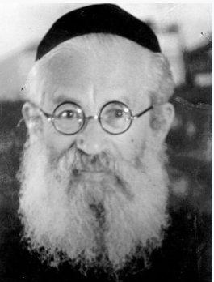

*Rabbi Herzog was the first Chief Rabbi of Ireland (1921-1936) and from 1936 until his petira in 1959 was the last Ashkenazi Chief Rabbi of the British Mandate of Palestine and first Chief Ashkenazi Chief Rabbi of the State of Israel. Rabbi Herzog’s son Chaim became the sixth president of Israel. His grandson – Yitzchak Herzog is the current president (head of state) of Israel, its 11th president.*

**Rav Avigdor Miller on**

**Is it an Aveira to Speed Through a Red Light**



**QUESTION:** Is it an aveirah to speed through a red light?

**ANSWER:** The answer is that it’s a very big sin – one of the biggest sins. First of all, you’re endangering your life. And a person who endangers his life should know that even though Hakodosh Boruch Hu has saved that man’s life, He will be collecting that man’s mitzvos from him.

It will cost that individual many years of tefillin! Many years of tefillin! Many years of kriyas shema! מנכין לו מזכויותיו – Hashem deducts from a man’s mitzvos when He saves him from a dangerous situation that he had put himself into. You’ll find out that making that red light wasn’t worth it at all.

In addition to that, you have put other people in danger as well which is a very severe crime. It’s considered as if you are a shoifech damim, even if you didn’t kill anybody. Because you put yourself in a situation where you could have killed someone, you’re considered a shoifech damim – potentially. And that’s a tremendous sin.

You must understand that. Just because nothing happened doesn’t mean that you’re not guilty. People who are reckless in their driving are doing something that is opposite from the will of Hashem and they are *asidin li’tein es hadin;*sooner or later they will be punished. (Tape # E-180 (April 2000)

*Reprinted from the January 21, 2022 email of Toras Avigdor. Adapted from Tape #583.*

**Understanding the True**

**Purpose of Holy Temple:**

**Spreading the Light of Holiness**

**From the Talks of the Lubavitcher Rebbe**

**Rabbi Menachem Mendel Schneerson, Zt”l**

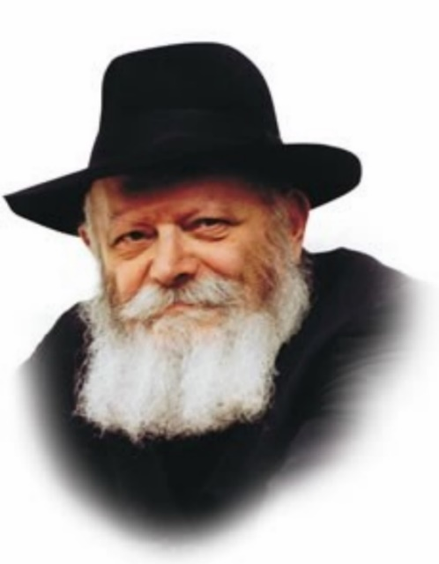

This week's Torah portion, Teruma, contains the commandment to fashion a menora for the Sanctuary. "And you shall make a menora of pure gold."

Maimonides, one of the greatest Torah scholars of all time, drew a detailed diagram of the menora which greatly helps us understand what it looked like. The diagram shows us the shape of the menora's branches, the location of its "flowers" and "bowls," and many other details.

Maimonides depicted the menora's bowls (which were actually tiny cups) in the shape of triangles. A cup is similar to a triangle as it is usually wider on the top and narrower on the bottom.

Surprisingly, however, Maimonides drew the bowls of the menora upside-down! All 22 of the bowls are depicted as inverted triangles, the wider part on the bottom and the narrower part at the top.

Thus, according to Maimonides' drawing, the bowls of the menora were designed as if to pour their contents out.

What does this teach us? Why were the bowls of the menora upside-down?

In truth, the bowls are symbolic of the function of the menora and, by extension, the Holy Temple.

A regular menora or candelabrum is designed to illuminate the inside of one's home. The menora in the Sanctuary, by contrast, was designed to illuminate the outside. Even without the menora the Temple was well lit. The reason it was kindled was to illuminate the world at large and demonstrate that G-d's Presence rested upon Israel.

The windows of the Holy Temple were fashioned according to the same principle. These unique windows were opaque from within yet transparent from without. Unlike other windows they did not draw light inside, but carried the light of the Holy Temple outward.

Similarly, a regular cup is designed to contain liquid. But the bowls of the menora were inverted, shaped like cups that pour their liquid out for those who are thirsty!

The true purpose of the Temple (and the menora) was to shine the light of holiness upon the entire world, not to contain it within its walls. Both its windows and the bowls of the menora expressed this concept, reflecting their primary function of imbuing the world with a holy illumination. For the Holy Temple is the place which lights up the entire world.

From this we learn an important lesson: The light of Torah and mitzvot must not be kept to ourselves. Rather, we must always strive to share it with others, thereby illuminating the world at large with holiness.

*Reprinted from the Parshat Teruma 5757/1997 edition of L’Chaim. Adapted from Likutei Sichot Vol 21.*

**Thoughts for Our Parsha**

*You shall make a table of acacia wood two cubits long, one cubit wide, and one cubit and a half in height.* (Exod. 25:23)

Inviting guests and feeding the needy are both great mitzvot, but very often people overspend on lavish table expenses in order to make a good impression. They may do this at the expense of giving charity or paying tuition. The Torah teaches us that the "width" (expansiveness) should not exceed one's material "height." *(From Our Ancient Treasures)*

*Reprinted from the Parshat Teruma 5757/1997 edition of L’Chaim. Adapted from Vedibarta Bam by Rabbi Moshe Bogomilsky*

**Do We Really Desire**

**The Land of Israel?**

**By Daniel Keren**

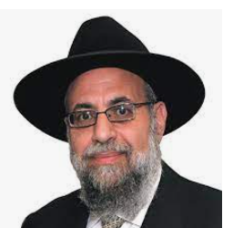

One of the highlighted speakers at last month’s Martin Luther King Jr. Day Hakhel Event in Flatbush was Rabbi Chaim Aryeh Zev Ginzberg, Rav of the Chofetz Chaim Torah Center in Cedarhurst and internationally renowned Maggid Shiur and educator. The topic of his lecture was “Properly Relating to a World in Turmoil.”

Rabbi Ginzberg said that today, we are in the same matzav (difficult position) as the Bnei Yisroel (the Children of Israel) were when suffering from the danger of the attacking Egyptians before Krias Yam Suf (the splitting of the Sea of Reeds). Eretz Yisroel (the Land of Israel) is today challenged by the threat of Iran which for the past 25 years has been threatening to unleash their deadly missiles against [the people of] Israel.

**Confused by Which Options to Pursue**

The Ramban (Rabbi Moshe ben Nachman, zt”l, 1194-1270) says that just before the coming of Moshiach (the Messiah), the Jews in Eretz Yisroel will be similarly challenged like their forefathers at Krias Yam Suf. They will be confronted by dangerous difficulties and will not sure of which options to pursue.

One medieval commentator says that when one learns Torah in Eretz Yisroel it is such a great zechus (merit) as to allow one to go directly to Olam Habah (the World to Come).

Rabbi Ginzberg referred to a Midrash that predicts a time will come before the coming of Moshiach when one will not be able to travel to Eretz Yisroel. In recent years, it became very easy to fly to the Promised Land. And then Hakodesh Baruch Hu unleashed a megefah (plague – the Corona virus) and we suddenly found ourselves locked out. Why? What was the purpose? Hakodesh Baruch Hu wants us to yearn to be able to enter Eretz Yisroel.

Why did the Chofetz Chaim want to go to Eretz Yisroel? He explained that before Moshiach comes and the Chofetz Chaim knew that we were and still are in the days of ikvus hamoshiach (the footsteps of the Moshiach) and that in these times, it will be very difficult for one to be allowed entry in Eretz Yisroel after the arrival of Moshiach.

**The Frustrated Desire of the Chofetz Chaim**

And the Chofetz Chaim was not sure that he himself would be worthy of being allowed to come to Eretz Yisroel. But he thought that if perhaps he could manage to come to the holy land before the coming of Moshiach, once he was in the Promised Land, that maybe he was good enough that perhaps they would allow him to remain. Unfortunately, despite his sincere efforts to travel and live in the holy land, circumstances in his life did not allow him to fulfill this great desire of his.

The Vilna Gaon (Rabbi Elijah ben Shlomo Zalman, zt”l, 1720-1797) writes that in the days before the coming of Moshiach, the Jews governing the Jewish people will be from the eruv rav (the disastrous mixed multitude of non-Jews that came out of Egypt and made the golden calf idol and caused so much trouble to the Bnei Yisroel, the Children of Israel).

And we see that fulfillment today, said Rabbi Ginzberg with a Jewish government in the holy land that is trying to make devastating changes to kashrus (kosher supervision), gairus (rules for converting gentiles to Judaism), Shabbos (by allowing buses to operate on the holy day of rest and also by destroying the sanctity of the Kosel (the Western Wall) – changes that even Dovid Ben Gurion [no friend of the Torah way-of-life] would never have imagined or tried to pursue.

**Is Florida a Better Option than the Holy Land?**

Rabbi Ginzberg told of a shocking story about a man who he knew and was always meeting when he was travelling in Eretz Yisroel. He met him recently and asked how things were. The man told that since the lockdown and the closing of the holy land to foreigners, he had bought a house in Florida.

He admitted that it was much easier and enjoyable for him to travel to Florida for a weekend. For one thing, he didn’t have to deal with jet lag. Rabbi Ginzberg was shaken by that man’s cavalier attitude to not being able to go to Eretz Yisroel. If too many of us get comfortable with weekend trips to Florida and stop having a yearning for Eretz Yisroel, we might not have the ability to come to the Promised Land after the coming of Moshiach.

Rabbi Ginzberg pointed out that Hakodesh Baruch Hu is inspiring hundreds, thousands, maybe even millions of Arabs from Eretz Yisroel and surrounding lands (i.e., Syria that will after the coming of Moshiach become a part of Eretz Yisroel) to leave their homes and immigrate to Europe, America and other parts of the world; thus making it easier for Jews to live more securely in the holy land.

We shouldn’t take Eretz Yisroel for granted. Rabbi Ginzberg recalled that the German General Erwin Rommel, yemach shemo, and his Afrika Korps was dashing across North Africa and the secular Jewish Agency leadership in Eretz Yisroel was very much afraid that he would come into the Land of Israel and try and put into practice the dreaded final solution of Adolf Hitler (yemach shemo).

Rommel wrote at that time that he was planning to shortly enjoy a cup of coffee in Tel Aviv. Baruch Hashem, he was foiled by the mercy of Hashem who allowed the British to destroy his military forces at the Second Battle of El Alamein in1942. Let us daven and hope for the continued kindness of Hakodesh Baruch Hu in protecting the Yidden living in the Promised Land.

*Reprinted from the February 3, 2022 issue of the Jewish Connection.*

**More Thoughts that Count for Our Parsha**

*Let them take for Me an offering* (Exod. 25:2)

Would it not be more correct to say, "They should give an offering"? When a Jew gives charity, he is not only giving, but he is also receiving merit for the mitzva, through which he will get back from G-d ten times more than he gave. Thus, by giving for the Tabernacle, the Jews were "taking" from G-d much more than they gave. *(Efriyon)*

*They shall make an Ark 2 1/2 cubits in length, 1 1/2 cubits in width, and 1 1/2 cubits in height* (Exod. 25:10)

All of the measurements of the Ark included fractions. The Ark, which contained in it the Tablets, represents Torah study. The measurements teach us that people who learn Torah must always bear in mind that regardless of how much they learn, they do not master it all. The extent of their knowledge is only a fraction of the vast teachings and depth of the Torah. *(Klei Yakar)*

*Reprinted from the Parshat Teruma 5757/1997 edition of L’Chaim. Adapted from Vedibarta Bam by Rabbi Moshe Bogomilsky*

**Hey! What’s That**

**Thing on Your Head?**

**by**[**Rabbi Shraga Simmons**](https://www.aish.com/authors/48865357.html)



***What is a yarmulke and why do Jewish people wear it?***

It is perhaps the most instantly identifiable mark of a Jew.

In the Western world, it is customary to remove one's head covering when meeting an important person. In Judaism, *putting on* a head covering is a sign of respect.

In the Talmud, it says that the purpose of wearing a yarmulke is to remind us of G-d, who is the Higher Authority "above us". External actions create internal awareness; wearing a symbolic, tangible "something above us" reinforces that idea that we also have a spiritual purpose.

It's easy to remember spirituality while at the synagogue or during the holidays. But Jewish consciousness is meant to pervade all aspects of our lives – how we treat others, how we conduct business, and how we look at the world.

Appropriately, the Yiddish word for head covering, "yarmulke," comes from the Aramaic, *yira malka*, which means "awe of the King."

In Hebrew, the head covering is called "kippah" – literally "dome."

**Making a Statement**

To wear a kippah is to proclaim "I am a proud Jew." Indeed, wearing a yarmulke is a big statement, and psychologically obligates the wearer to live up to a certain standard of behavior. A person has to think twice before cutting in line at the bank, or berating an incompetent waiter. Wearing a yarmulke, in a sense, makes one a Jewish ambassador, as if his actions reflect on all Jews.

Of course, putting on a yarmulke does not automatically confer "role model" status. Sometimes we unfortunately hear of a religious person caught in some indiscretion. I recall one time in Los Angeles, noticing that a drunken, disheveled man was walking down the street – wearing a yarmulke! He wasn't Jewish, but he'd found an old kippah and thought it helped him fit in with the neighborhood atmosphere. For me, it drove home the idea that it's not fair to "judge Judaism" based on someone displaying the outer trappings of observance.

**When to Wear a Yarmulke?**

There is no biblical requirement to wear a yarmulke. Yet for many centuries, the custom has been for Jewish men to wear a yarmulke all the time.

What kind of head covering qualifies? Basically anything – including a baseball cap or a scarf tied around one's head. Of course, in the synagogue, some feel it is more respectful to use a regular yarmulke.

**Business Questions**

What about instances were wearing a yarmulke conflicts with business and career interests?

If your question has to do with possible ramifications in Jewish law, there is room to be lenient. For example, a trial lawyer might not be properly serving his client if the jury will be distracted by the yarmulke. Former U.S. Senator Joe Lieberman may have used a similar line of reasoning.

Of course, this can cut both ways. A prominent businessman once told me that for every client "lost" because of his kippah, he gained two others who respected his display of integrity and courage in wearing a kippah.

*Reprinted from the Parshat Teruma 5782 website of Aish.com*

**Esther Pollard Passes Away**

**By** [**Jewish Press News Desk**](https://www.jewishpress.com/author/newsbriefs/)

[](https://www.jewishpress.com/wp-content/uploads/Esther-Pollard.jpg) Esther Pollard, wife of convicted Israeli spy Jonathan Pollard, speaks to press outside her home in Jerusalem on July 29, 2015. (Photo by Flash90)

[Esther Pollard](https://www.jewishpress.com/sections/in-memoriam/esther-pollard-a-true-woman-of-valor-2/2022/01/31/), the wife of Jonathan Pollard, passed away at Jerusalem’s Hadassah Ein Kerem Medical Center. She had been [rushed to the hospital on Saturday](https://www.jewishpress.com/news/health-and-medicine/coronavirus/esther-pollard-rushed-to-hadassah-with-covid/2022/01/30/) after her health deteriorated. She had breast cancer and was also fighting off Covid-19.

The funeral will be held on Monday at Har HaMenuchot Cemetery in Jerusalem at 4 PM.

Esther Zeitz was born in Montreal, Canada. She and Jonathan Pollard actually met in 1971 when they were both teenagers on an Israeli youth program. They had discussions about their mutual love for the land and people of Israel, but then returned to their homes – he to South Bend, Indiana, and she to Montreal, not even dreaming that they would meet again.

While in prison, Jonathan [shared his own thoughts](https://www.jewishpress.com/sections/in-memoriam/esther-pollard-a-true-woman-of-valor-2/2022/01/31/) on his marriage in a message to a Jewish magazine from his prison cell in Butner, North Carolina. “We are taught that a wife is *an eizer k’negdo*, a helpmate to her husband; she complements and completes him, facilitates his agenda. We also have the concept of *bashert,* two people meant for each other. These concepts don’t go far enough in describing my feelings for Esther. She is my*bashert*, but much more than that. She is my *eizer*, but much more than that. She enables me to live this kind of existence with hope for now and for the future.

“Esther allows me to get up every morning in this devastating environment and to feel hope, to know that Hashem gave me a wonderful and loyal wife, and to live each day believing that in the wink of any eye He will bring me home to her.”

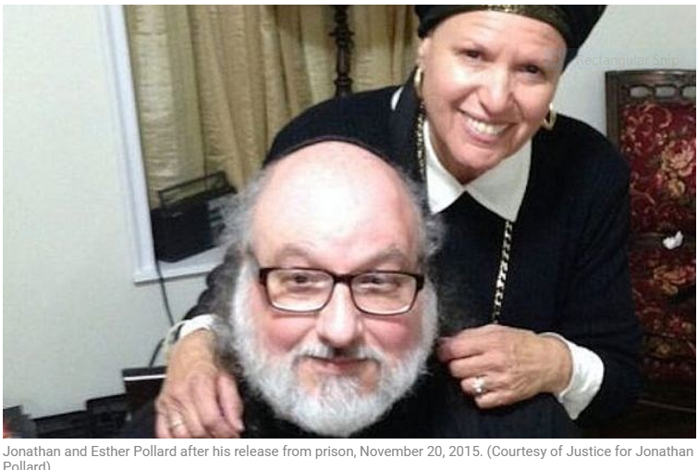

Jonathan Pollard’s words summarize the essence of Esther, the consummate *Eishet Chayil*, Woman of Valor, the Jewish wife who brought about the greatest miracle in this tragic tale.

MK Bezalel Smotrich has requested that the Knesset session opening be delayed this afternoon, to allow government representatives to be at the funeral and pay their proper respects.

*Reprinted from the January 31, 2022 email of the Jewish Press.*